**Eyyub Aghamoghlanov**

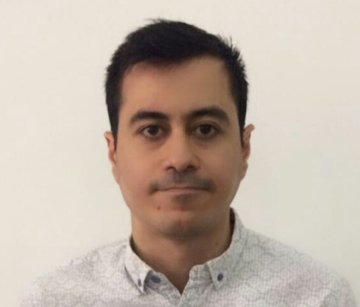

Address: Z.Khalilov str., section 523, house 16a, apt 6

Telephone: mob: (+994) 51 594 63 34

E-mail Address: e[.aghamoghlanov@gmail.com](mailto:aghamoghlanov@gmail.com)

Place of Birth: Baku, Azerbaijan

Nationality: Azerbaijani

**Qualifications: Languages**:

• Azerbaijani – native

• Russian – fluent

• English – fluent

**I.T Skills**

• Advanced PC User (Microsoft Office – Word, Excel, Outlook, Power Point, Internet explorer)

• AutoCAD, 3D Studio Max.

• HTML, CSS, JavaScript, Bootstrap, Jquery, C#, SQL Database,.

**Activities/Awards**

*.*

* Completed Full Stack Web Development course

*Baku, Azerbaijan - November 2021 – June 2022*

* Successfully completed the training course for “Wireline Engineering”. Received a certificate.

*Baku, Azerbaijan - 13.07.2018*

* Master thesis work was presented at GEO 2018 - 13th Middle East Geosciences Conference and Exhibition

*Manama, Bahrain - 06/03/2018*

* Presented my master thesis work on Schlumberger Geology Day online conference

*Stavanger, Norway - 15/09/2015*

* Presented my research work about “Oil Shale”, at SEG (Society of Exploration Geophysicist’s) student chapter conference.

*Baku, Azerbaijan - 21/11/2009*

**Education:**

• Msc in Petroleum Geosciences Engineering, University of Stavanger 2013 – 2015

• Bsc in Oil and Gas Geology, Azerbaijan State Oil Academy 2007– 2011

• High School №20 1996 - 2007

**Employment History:**

• Pharm Line - Baku, Azerbaijan June 2020 – Present

**International Relations Manager**

**Responsibilities:**

o *Establishing business relationships with international companies*

o *Preparing, signing and sending distribution agreements*

o *Creating a detailed forecast for orders*

o *Preparing all the necessary documentation for product registration*

o *Preparing reports on completed work*

• NPC Agro LLC - Baku, Azerbaijan June 2019 – April 2020

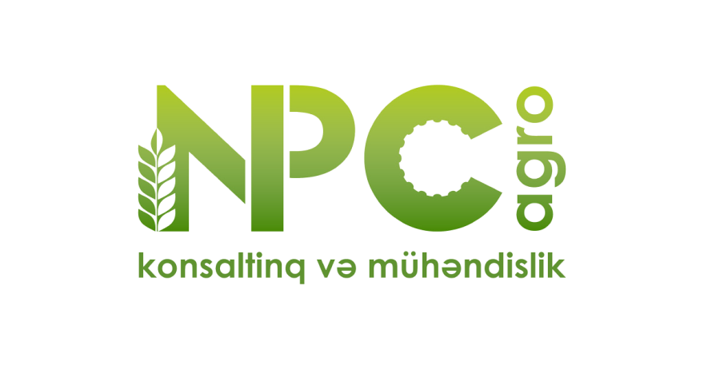Soil EC Mapper

**Responsibilities:**

o *Measuring soil EC via EM38 MK2 (electromagnetic scanner)*

o *Collecting, converting and processing measured raw data in RTM38MK2*

o *Transferring and interpolating data in QGIS*

o *Creating Soil EC and Field Management maps*

• Pharm Line - Baku, Azerbaijan March 2017 – June 2019

**International Relations Manager**



**Responsibilities:**

o *Establishing business relationships with international companies*

o *Preparing, signing and sending distribution agreements*

o *Creating a detailed forecast for orders*

o *Preparing all the necessary documentation for product registration*

o *Preparing reports on completed work*

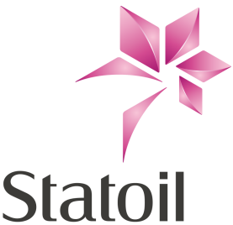• Statoil - Stavanger, Norway June 2014 – August 2014

**Geologist - Summer intern**

**Responsibilities:**

o *Digitalizing well data into WellCAD*

o *Converting and importing digitalized data in Wellmaster (RMS)*

o *Analyzing Lithofacies proportions ,KLH Core and KLV Core statistics*

o *Creating SBED models*

o *Running up Reservoir Studio Model*

• Qrunt Geo LTD - Baku, Azerbaijan April – September 2012

**Geologist**



**Responsibilities:**

o *Collecting****,*** *analyzing and classifying cores and rocks precisely.*

o *Packing all the samples for the future laboratory analysis*

o *Preparing reports on completed field works and findings*

o *Supervising field technicians during field work and investigation*

**REFERENCES:**

Daniel Berge Sollien (Geologist) - **mob:** +4748123018; **e-mail:** [dbs@statoil.com](mailto:dbs@statoil.com) Andrew Simms (Geologist) - **mob:** +4746930167; **e-mail:** [ANSIMM@statoil.com](mailto:ANSIMM@statoil.com) Bhaskar Satyavolu (Geologist) - **mob:** +4795360232; **e-mail:** [BHSAT@statoil.com](mailto:BHSAT@statoil.com) Kari Nordaas Kulkarni (DPN OS SN PTC) Team leader – **e-mail**: [kanoku@statoil.com](mailto:kanoku@statoil.com)